Install Python GUI
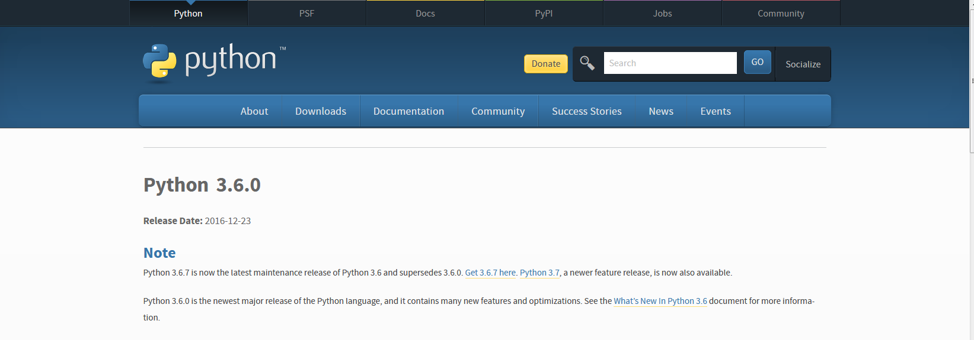

(make sure you are downloading the latest python version)
- From https://www.python.org/downloads/
- Run the file
3. Select install for all users or install just for me, click Next
4. You'll see it installs under the C:\Python36 folder (or something similar), click Next
5. Click Next again for the 'Customize Python' step
6. Click Finish
7. Open windows explorer, then go to all programs
8. Look for python verison
9. Click the “IDLE (Python GUI)”

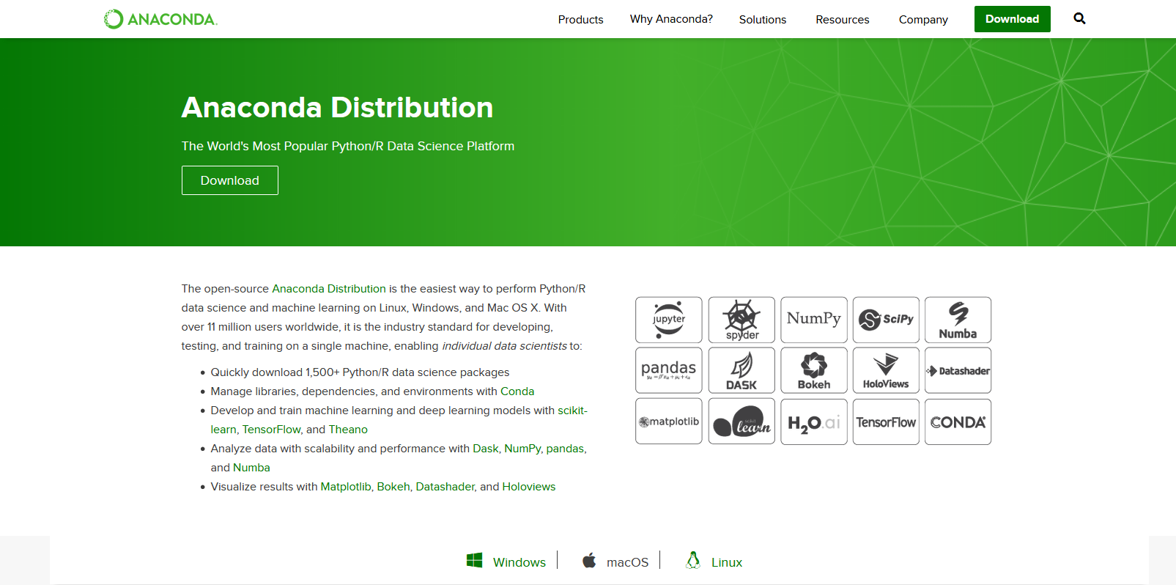
Install Anaconda Jupyter Notebook Python
(Best to download using Google Chrome browser)
- Go to https://www.anaconda.com/distribution/ select windows 64 or 32 bit. If you have an older (5 years or older) model computer use 32 bit.
- Wait for the executive file to download.
- Select the executive file and go through the dialog box prompts.

